**Arlington Chess Club**

 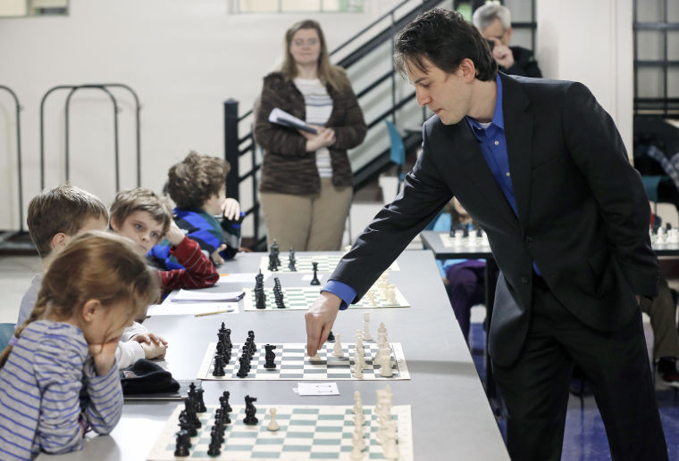

**♔ Simul: GM Sergey Erenburg ♖**

**Saturday, April 2, 2016 (Lecture: 1:30pm / Simul: 2:30pm)**

GM Sergey Erenburg will give a 1-hour chess lecture with Q&A before taking on all challengers in a Simultaneous Exhibition match at the Arlington Chess Club. Erenburg was born in Russia and immigrated to Israel when he was 15 where he first won the Israeli national championship in 2004 at the age of 21. He also placed 2nd in the World Team Championship (2005) before attending the University of Maryland Baltimore County where he helped the UMBC team earn two US Collegiate Championships (2008, 2009).

**Lecture + Simultaneous Exhibition Match**

**Register:** 1:00 – 1:30pm **Lecture:** 1:30 – 2:30pm **Simul Games:** 2:30pm – End of Last Game

**Time Control:** None. Just be ready to move when GM Erenburg returns to your board.

**“Passes:”** Each player to get up to 3 “passes” instead of forced to move on GM’s return.

**Color:** TBD – based on entries; GMs usually expect White on all boards.

**Entry Fee:** **$35 ($30** for ACC members**)**; **$20** lecture-only; Cash/Check Only On-site (NO Credit)

**To Pre-Register On-line, go to:** [www.arlingtonchessclub.com/PayPal2.html](http://www.arlingtonchessclub.com/PayPal2.html)

**Location:** Arlington Forest United Methodist Church located at 4701 Arlington Blvd. at intersection with N. Henderson Road. Enter from parking lot through basement door off N. Henderson Road.

**General ACC Information:** Annual dues are $75 ($60 for Kids/Seniors). Players must also be U.S. Chess Federation members to participate in most club events. **Blitz / Action / Action-Plus / Quad / Scholastic Tournaments:** Play 3-5 round tournaments with discounted entry fees for members. **Club Championships:** Various events held annually. **D.C. Chess League:** Club teams compete against other area teams. **Simultaneous Exhibitions:** 1-2 times/year Grand Masters give an hour lecture, then play 25+ challengers. **Questions:** [chrisney2@gmail.com](mailto:chrisney2@gmail.com)See **ACC website** at: [www.arlingtonchessclub.com](http://www.arlingtonchessclub.com) **ACC meets every Friday at 7:00pm.**

**General ACC Information:** Annual dues are $50 ($40 for Kids/Seniors). Players must also be U.S. Chess Federation members to participate in most club events. **Blitz / Action / Action-Plus / Quad / Scholastic Tournaments:** Play 3-5 round tournaments with discounted entry fees for members. **Club Championships:** Various events held annually. **D.C. Chess League:** Club teams compete against other area teams. **Simultaneous Exhibitions:** 1-2 times/year Grand Masters give an hour lecture, then play 25+ challengers. **Questions:** [chrisney2@gmail.com](mailto:chrisney2@gmail.com)See **ACC website** at: [www.arlingtonchessclub.com](http://www.arlingtonchessclub.com) **ACC meets every Friday at 7:00pm.**