Arlington Chess Club
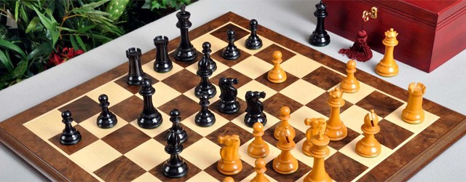
K Chess Ladder r
EVERY FRIDAY: Play games against opponents with a similar rating!!

The Arlington Chess Club (ACC) normally opens every Friday at 7:00p.m. Be sure to bring your own equipment!!
Ladder Info

1 Game Every Friday

Register: 7:00 – 8:00 p.m.
Games begin circa: 8:10 p.m.

Time Control:
30/90, SD/60, d/5

Entry Fee: None!

Comes with ACC membership, USCF Membership also required.

Monthly Prize: $50
For Best Record over 4-5 Fridays.
Location: Arlington Forest United Methodist Church
4701 Arlington Blvd.
Enter through basement door.

Send any questions to: chrisney2@gmail.com

ACC currently meets at the Arlington Forest United Methodist Church which is located at: 4701 Arlington Blvd (at intersection with N. Henderson Road). Find out more information about the ACC club on our *NEW* website which can be found at: http://www.arlingtonchessclub.com

Questions about membership, tournaments and other club information can be directed to: chrisney2@gmail.com.

To receive ACC’s e-mail news bulletins, send an e-mail to: chrisney2@gmail.com

General ACC Information: Annual dues are $50 ($40 for Kids/Seniors). Blitz Tournaments: Play a 5 round G/5, d/3 “Swiss” tournament; $15.00 entry fee with cash prizes based on the number of entries. Action Tournaments: Play 3 rated games at a G/30, d/5 time control; entry $15, slightly less for ACC members. D.C. Chess League: Master/Expert teams compete against other area clubs. Simultaneous Exhibitions: 1-2 times/year Grand Masters provide an hour lecture and then play 25+ challengers for a modest fee. Club Championships: Regular, Action, and Blitz events held annually. For most club rated games or events, members must also be U.S. Chess Federation members.

